Benign and Pre-malignant lesions of the mouth

Venue:
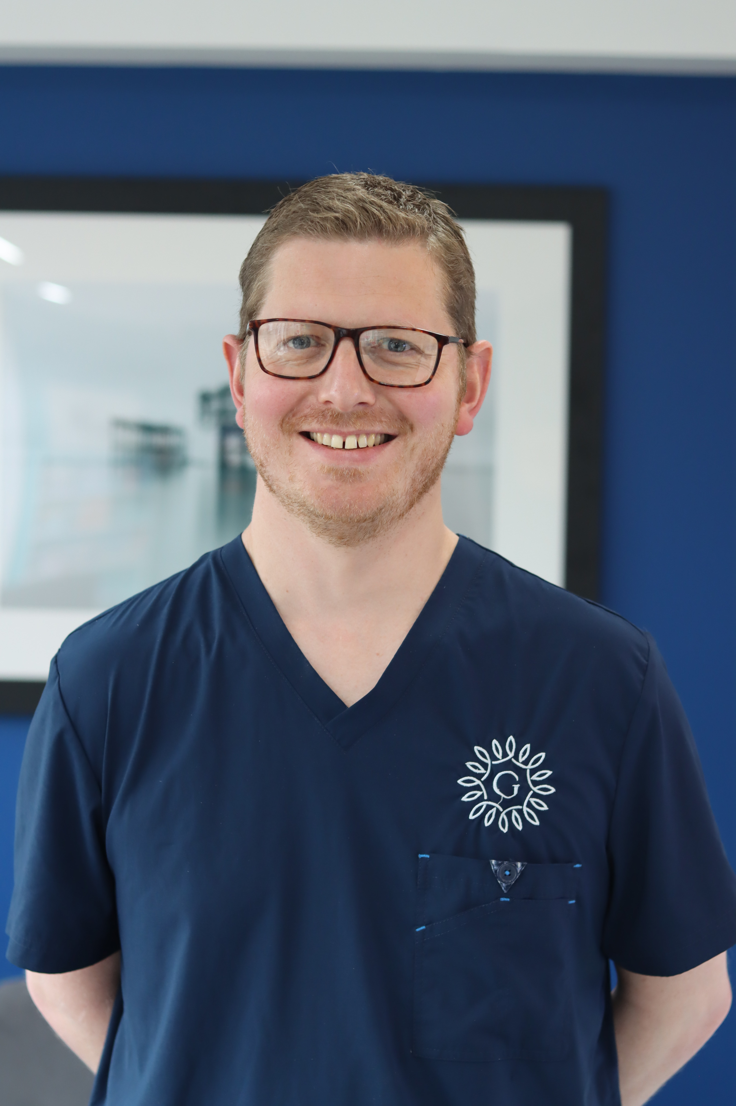
Mr James Padgett
Consultant in Oral &
Maxillofacial Surgery
Graystone Referral Centre, Hassocks, Sussex
Wednesday 1st July 2026

Time:
Registration & Refreshments: 1830

Lecture: 1900 – 2100

Aim:
To allow appropriate management of benign and
pre-malignant oral lesions in dental practice

Objectives:
To allow clinicians to:
Recognise common benign lesions of the mouth
Recognise pre-malignant conditions of the mouth
Know when to refer and when to monitor

Please contact Dentinal Tubules to join the “Brighton Study Club” and register your place for this lecture.

